

**Signals and Systems**

Lab Report#07

# Name:

Taha Saeed

**Registration number:**

FA18-EEE-032

**Submitted to:**

Dr. Ghufran Shafiq

**In-Lab Tasks**

**Task 01: Suppose that a LTI system is described by impulse response. Compute the response of the system (by both methods) to the input signal**



**Solution:**

**Method 1:**

t1 = [-1:0.01:0.5];

t2 = [0.6:0.01:3];

t = [t1 t2];

x1 = ones(size(t1)).*0.6;

x2 = ones(size(t2)).*0.3;

x = [x1 x2];

h = exp(-t).*heaviside(t);

subplot(3,1,1);

plot(t,x);

title('x[n]')

grid on;

subplot(3,1,2)

plot(t,h)

title('h[n]')

grid on;

y = conv(x,h);

subplot(3,1,3)

plot(y)

grid on;

title('y[n]')

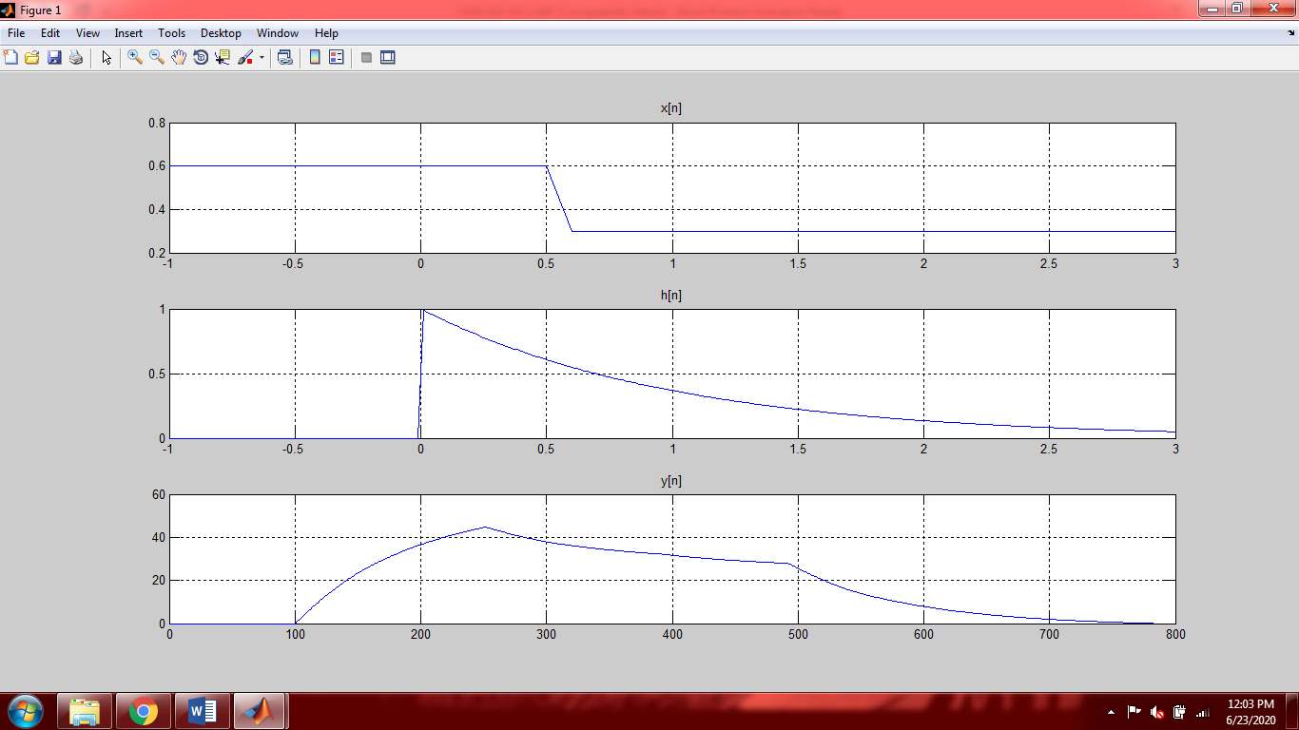

**Method 2:**

t1=[-1:0.01:0.5];

t2=[0.5+0.01:0.01:3];

t=[t1 t2];

x1=ones(size(t1)).*0.6;

x2=ones(size(t2)).*0.3;

x=[x1 x2];

h=exp(-t).*heaviside(t);

subplot(3,3,1)

plot(t,x,'b',t,h,'g','linewidth',3),grid on;

xlim([-1 1.5])

ylim([ -1 1.5])

title('Step 1');

legend('x(k)','h(k)')

subplot(3,3,2)

plot(t,x,'b',-t,h,'g','linewidth',3),grid on;

xlim([-1 1.5])

ylim([ -1 1.5])

title('Step 2');

legend('x(k)','h(-k)')

subplot(3,3,3)

p = -1.5;

plot(t,x,'b',-t+p,h,'g','linewidth',3),grid on;

xlim([-1 1.5])

ylim([ -1 1.5])

title('Step 3');

legend('x(k)','h(-1.5-k )')

subplot(3,3,4)

p = -0.5;

plot(t,x,'b',-t+p,h,'g','linewidth',3),grid on;

xlim([-1 1.5])

ylim([ -1 1.5])

title('Step 4');

legend('x(k)','h(-0.5-k )')

subplot(3,3,5)

p = 1;

plot(t,x,'b',-t+p,h,'g','linewidth',3),grid on;

xlim([-1 3])

ylim([ -1 3])

title('Step 5');

legend('x(k)','h(1-k )')

subplot(3,3,6)

p = 2.5;

plot(t,x,'b',-t+p,h,'g','linewidth',3),grid on;

xlim([-1 3.5])

ylim([ -1 3.5])

title('Step 6');

legend('x(k)','h(2.5-k )')

subplot(3,3,7)

p = 4;

plot(t,x,'b',-t+p,h,'g','linewidth',3),grid on;

xlim([-1 7])

ylim([ -1 3])

title('Step 7');

legend('x(k)','h(4-k)')

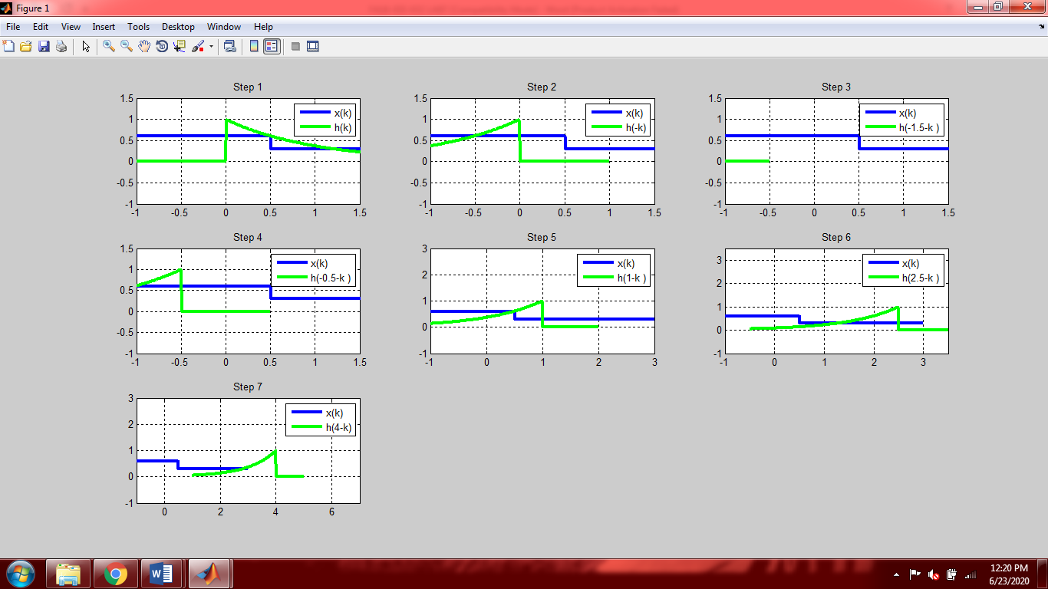

**Task 02: Compute (by both methods) and plot the response of the system**



**Solution:**

**Method 1:**

t1 = [0:0.01:0.99];

t2 = [1:0.01:2];

t3 = [2.01:0.01:10];

t = [t1 t2 t3];

x1 = zeros(size(t1));

x2 = ones(size(t2));

x3 = zeros(size(t3));

x = [x1 x2 x3];

h = x; %x(t) and h(t) are same

subplot(3,1,1);

plot(t,x)

title('x(t)')

xlim([-0.2 10.2])

ylim([-0.2 1.2])

subplot(3,1,2)

plot(t,h);

title('h(t)')

xlim([-0.2 10.2])

ylim([-0.2 1.2])

subplot(3,1,3)

y = conv(x,h).*0.01;

yt = 0:0.01:20;

plot(yt,y);

title('y(t)=x(t)*h(t)')

xlim([-0.2 10.2])

ylim([-0.2 1.2])

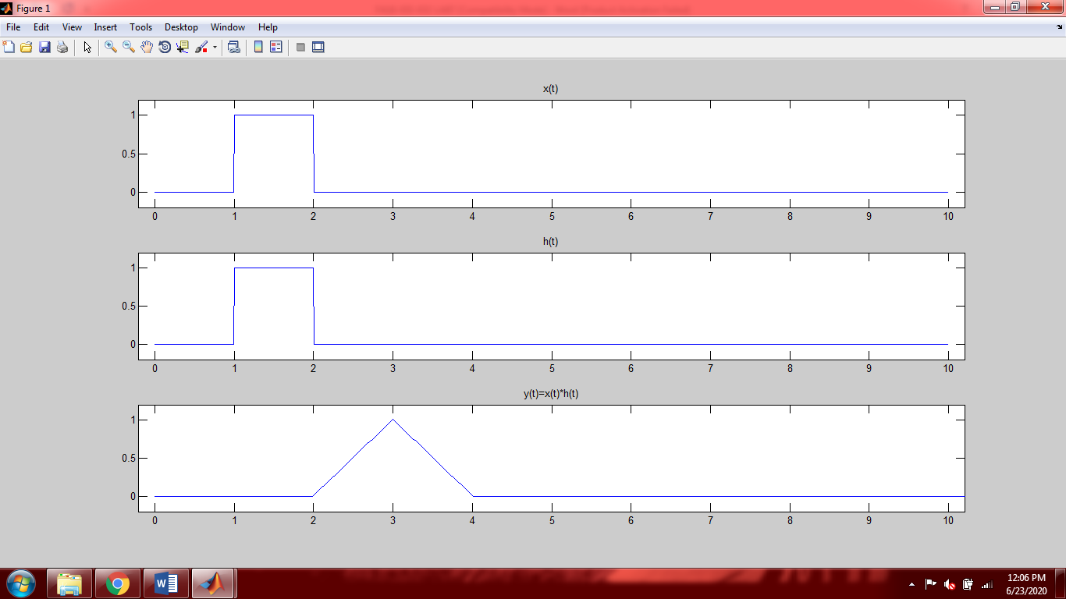

**Method 2:**

t1 = [0:0.01:0.99];

t2 = [1:0.01:2];

t3 = [2.01:0.01:10];

t = [t1 t2 t3];

x1 = zeros(size(t1));

x2 = ones(size(t2));

x3 = zeros(size(t3));

x = [x1 x2 x3];

h = x; %x(t) is same as h(t)

subplot(3,2,1)

plot(t,x,-t,h,'g','LineWidth',2)

legend('x(k)','h(-k)')

ylim([-0.2 1.1])

grid on

p = 2.5;

subplot(3,2,2)

plot(t,x,'b',-t+p,h,'g','LineWidth',2)

legend('x(k)','h(2.5-k)','Location','west')

ylim([-0.2 1.1])

grid on

p = 3;

subplot(3,2,3)

plot(t,x,'b',-t+p,h,'g','LineWidth',2)

legend('x(k)','h(3-k)','Location','west')

ylim([-0.2 1.1])

grid on

p = 3.5;

subplot(3,2,4)

plot(t,x,'b',-t+p,h,'g','LineWidth',2)

legend('x(k)','h(3.5-k)','Location','west')

ylim([-0.2 1.1])

grid on

p = 4;

subplot(3,2,5)

plot(t,x,'b',-t+p,h,'g','LineWidth',2)

legend('x(k)','h(4-k)','Location','west')

ylim([-0.2 1.1])

grid on

p = 4.5;

subplot(3,2,6)

plot(t,x,'b',-t+p,h,'g','LineWidth',2)

legend('x(k)','h(4.5-k)','Location','west')

ylim([-0.2 1.1])

grid on

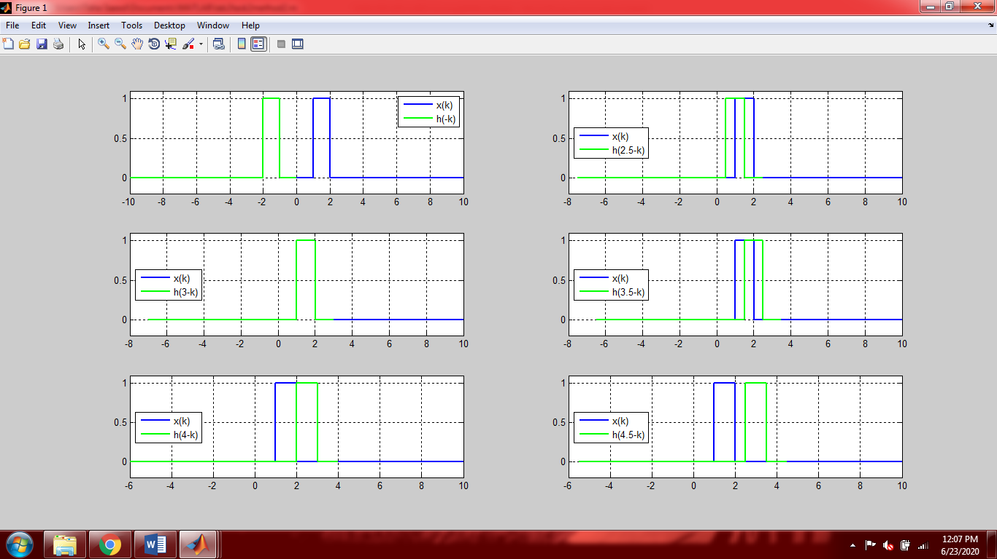

**Task 03: Suppose that a system is described by the impulse response . Compute (by both methods) and plot the response of the system to the input shown in figure below**

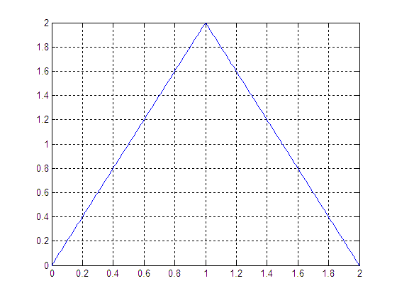

**Solution:**

**Method 1:**

t1=[0:0.01:1];

t2=[1+0.01:0.01:2];

t=[t1 t2];

x1=2.*t1;

x2=-2.*t2 + 4;

x=[x1 x2];

subplot(3,1,1)

plot(t,x)

grid on;

title('x[n]')

subplot(3,1,2)

t3=0:0.01:4;

h1=ones(size(t3));

h2=cos(2.*pi.*t3);

h=h2.*h1;

plot(t3,h);

grid on;

title('h[n]')

subplot(3,1,3)

y=conv(x,h).*0.01;

t4=0:0.01:6;

subplot(3,1,3)

plot(t4,y);

grid on;

title('y[n]')

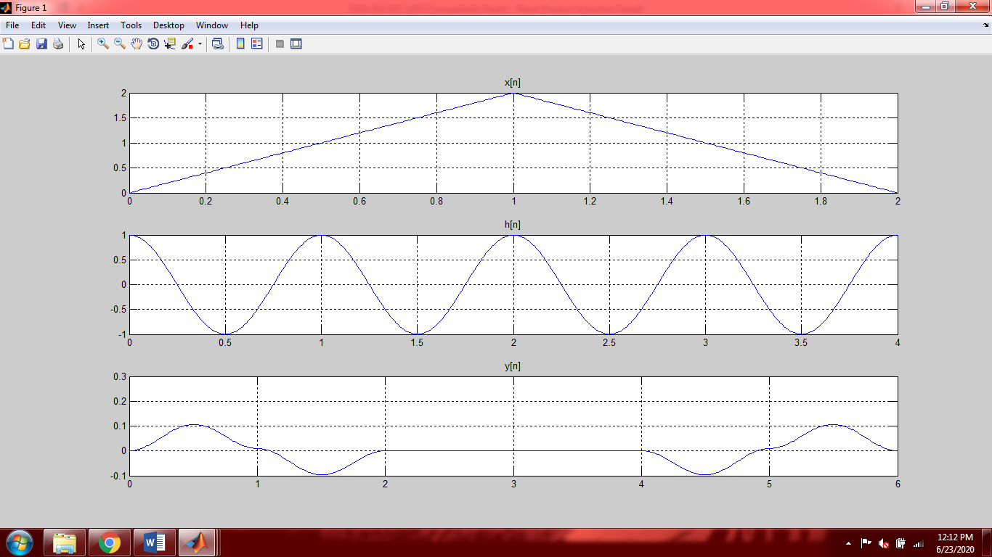

**Method 2:**

t1=[0:0.001:1];

t2=[1+0.001:0.001:2];

t3=[2+0.001:0.001:4];

t=[t1 t2 t3];

x1=2.*t1;

x2=-2.*t2 + 4;

x3=zeros(size(t3));

x=[x1 x2 x3];

n=0:0.001:4;

h1=ones(size(n));

h2=cos(2.*pi.*n);

h=h2.*h1;

subplot(3,2,1)

plot(t,x,'b',-t,h,'g','LineWidth',2),grid on;

legend('x(k)','h(-k)')

xlim([-5.5 5])

title('Step 1')

p=0.5;

subplot(3,2,2)

plot(t,x,'b',-t+p,h,'g','LineWidth',3),grid on;

legend('x(k)','h(0.5-k)')

xlim([-5.5 6])

title('Step 2')

p=1.5;

subplot(3,2,3)

plot(t,x,'b',-t+p,h,'g','LineWidth',3),grid on;

legend('x(k)','h(1.5-k)')

xlim([-5 6])

title('Step 3')

p=3.5;

subplot(3,2,4)

plot(t,x,'b',-t+p,h,'g','LineWidth',3),grid on;

legend('x(k)','h(3.5-k)')

xlim([-4 7])

title('Step 4')

p=5.5;

subplot(3,2,5)

plot(t,x,'b',-t+p,h,'g','LineWidth',3),grid on;

legend('x(k)','h(5.5-k)')

xlim([-3 8])

title('Step 5')

p=7.5;

subplot(3,2,6)

plot(t,x,'b',-t+p,h,'g','LineWidth',3),grid on;

legend('x(k)','h(7.5-k)')

xlim([-1 9])

title('Step 6')

## 

**Post-Lab Task**

## Critical Analysis / Conclusion

|  |
| --- |
| In this lab we performed convolution of two continuous time signals. There are two methods to perform convolution in Matlab.  1.Built in function:  There is a built in command in Matlab that allows you to perform convolution of the two signals.  2.Step by step Method:  In this method you have to perform all the steps of convolution i.e. reversal of any one signal, sliding that signal on the first signal and adding all the graphs obtained to get the convoluted signal. This is a very difficult and long method in comparison to the built in function. |